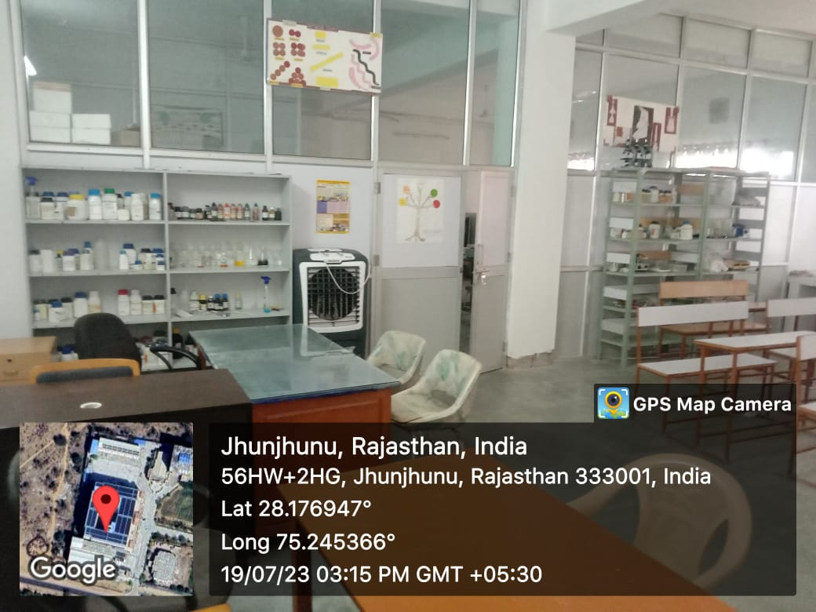

BIOTECHNOLOGYLAB

The Biotechnology laboratory is actively involved in to inculcate the scientific aptitude in students and research scholars to enrich their practical knowledge to support the theory part, covering multiple aspects of molecular biology, recombinant DNA technology, nutrition & food biotechnology, physiology, biochemistry, plant & animal biotechnology, and compound analysis. Presently, the Biotechnology laboratory is well equipped with modern and basic instruments that include: UV-Vis Spectrophotometer, Refrigerated Centrifuge, Circulating Water Bath, Electrophoresis units for DNA and protein analyses, pH Meter, Water Distillation Unit, Hot Air Ovens, Incubator, Autoclave, Electronic colony counters, Compound microscopes, and, Microbalance etc. The laboratory infrastructure is aligned to futuristic trends in industry and academia.

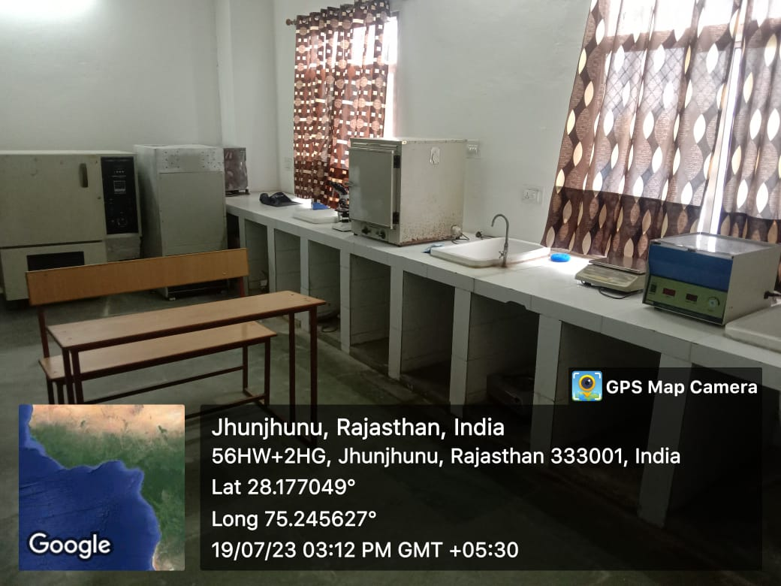

MICROBIOLOGY LAB

The Microbiology Laboratory offers diagnostic testing, antimicrobial and antifungal susceptibility testing, providing students with the fundamentals of microbiology combined with extensive, hands-on laboratory experience. The laboratory is specifically utilized for the isolation, identification culture and analysis of industrially important microorganisms (bacteria, yeast and fungi) for research into bioremediation, environmental microbiology, antimicrobial systems and diverse microbiological applications. The instruments available in the Microbiology Laboratory are Autoclave (Vertical),  Laminar Air Flow, Refrigerated Centrifuge, Analytical Weighing Balance, BOD incubator, BOD shaker cum incubator, Electronic colony counters, Compound microscopes, and, Microbalance etc.

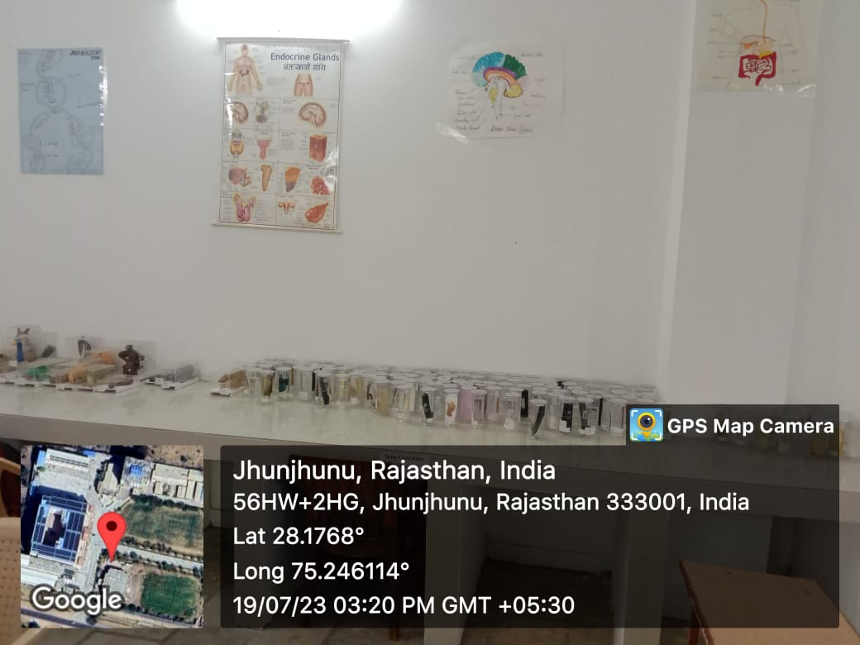

ZOOLOGY LAB

The Zoology Laboratory provides a suitable environment to develop a detailed understanding of the animal kingdom by exploring the physical, morphological and physiological characteristics of animals. The laboratory presents through its instruments an ideal place for students to study the histology of various cells, tissues and organs. Moreover, the laboratory has all the necessary infrastructure and equipments (Demos, Models, Charts, Compound Microscopes, Trinocular Microscope, pH Meter, Digital Weighing Balance) to conduct practicals in the basic and applied fields of Zoology. In addition, the laboratory is well stocked with more than 250 invertebrate and vertebrate specimens and osteological specimens of Human, Horse, Cow, Dog, Snakes, Birds and also that of aquatic forms including dolphin, crocodile, bones of whale etc. The laboratory is a rich repository of preserved insect specimens representing all insect orders which serve as a rich resource for researchers in Zoology, especially Entomology.

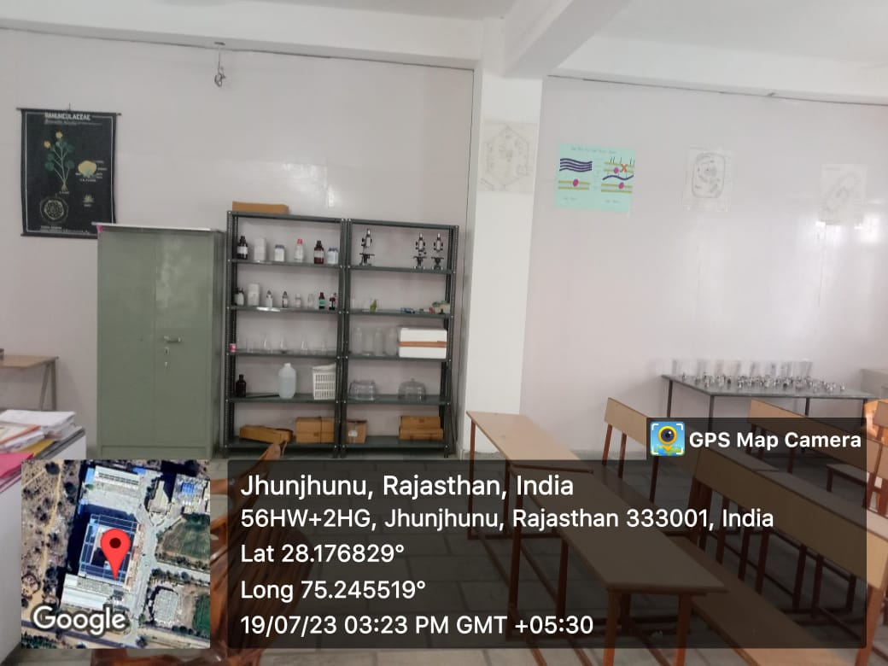

BOTANY LAB

Botany laboratory is well equipped with facilities to familiarize students with common experiments and principles necessary for a sound foundation in the plant sciences including the study of the structure, properties and biochemical processes of all forms of plant-life as well as plant classification, plant diseases and the interaction of plants with their physical environment. The laboratory is spacious, well ventilated and are equipped with the necessary instruments such as Dissecting Microscope, Compound Microscope, Binocular Microscope, Trinocular Microscope, Digital pH meter, Anemometer, Psychrometer, Luxmeter, Soil Thermometer, Photometer etc. Botany laboratory is also supplemented with a Herbarium rack, 3-D models, charts, specimens, glass slab, permanent slides to understand structure of various bio molecules and plants used regularly in practical classes.

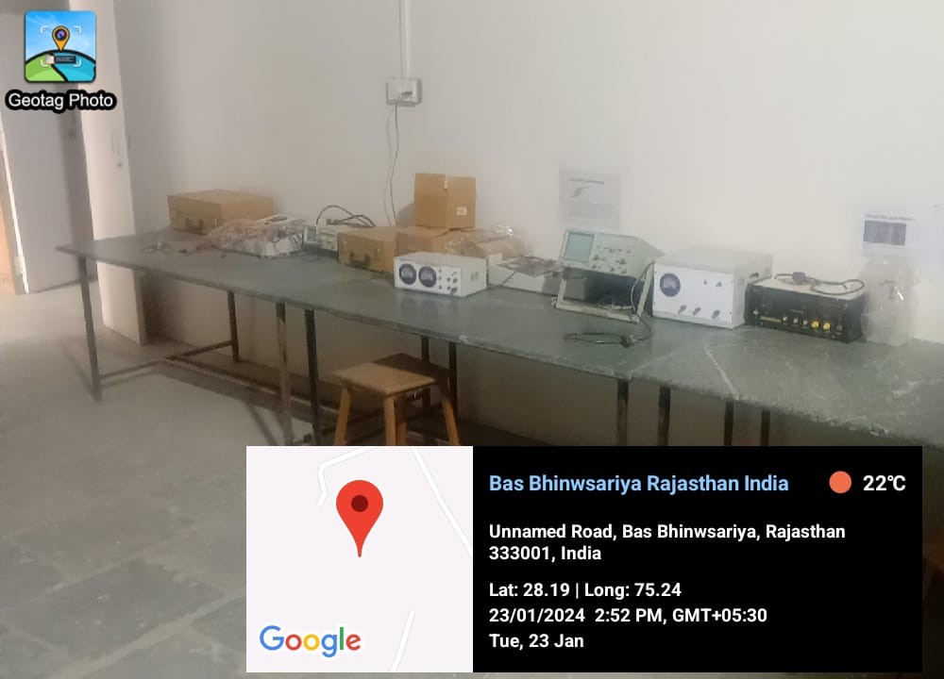

PHYSICS LAB ELECRONICS

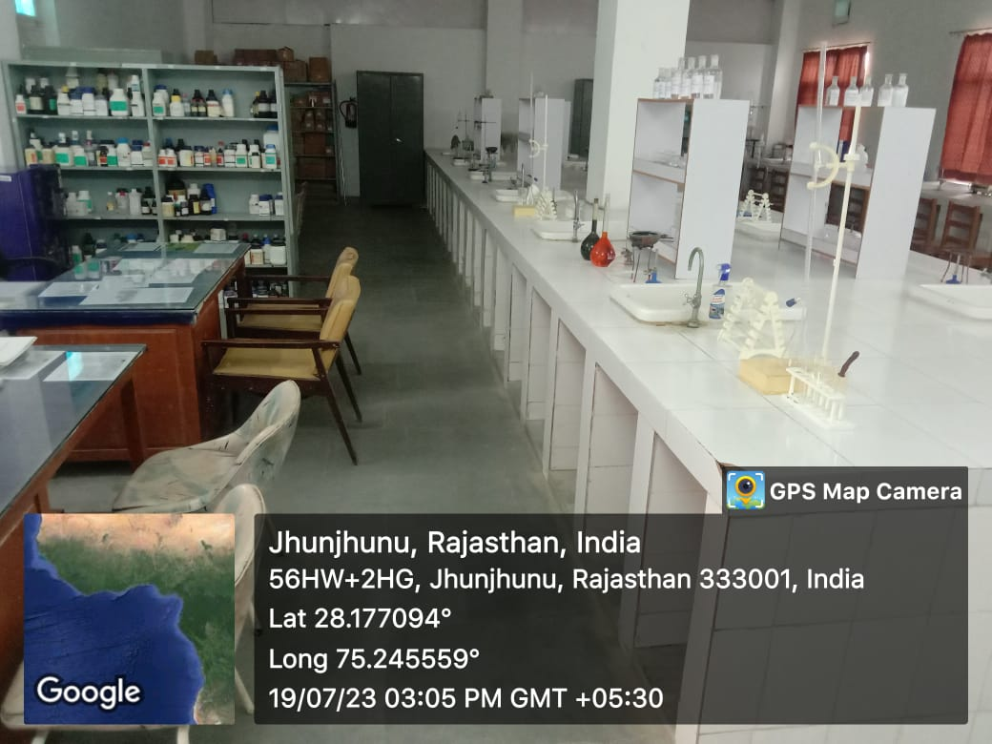

CHEMISTRY LAB